Lab 1: Active Directory & IAM Fundamentals

Objective
Create and manage users and groups in Active Directory, perform login testing, handle password resets, and troubleshoot common account issues.

Environment
- Virtual Machine: Windows Server (AD-Server)
- VirtualBox
- Domain: LAB
- Administrator account: LAB

Step 1: Verify AD Environment
- Open Server Manager → Tools → Active Directory Users and Computers
- Navigate to LAB → Users
- Confirm existing users and groups:
  - Users: jdoe, [second user]
  - Groups: LabAdmins
Screenshot: Lab1_AD_Users.png
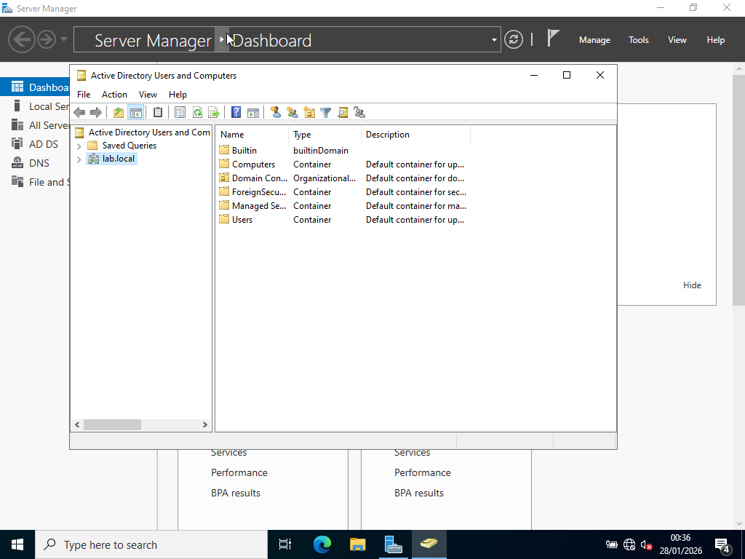

Step 2: User Login Testing
- Sign out from LAB
- On the login screen, select Other User (or manually type the username)
- Log in as LABwith password Pass@1234
- Observe first login setup and desktop availability
Screenshot: Lab1_UserLogin.png
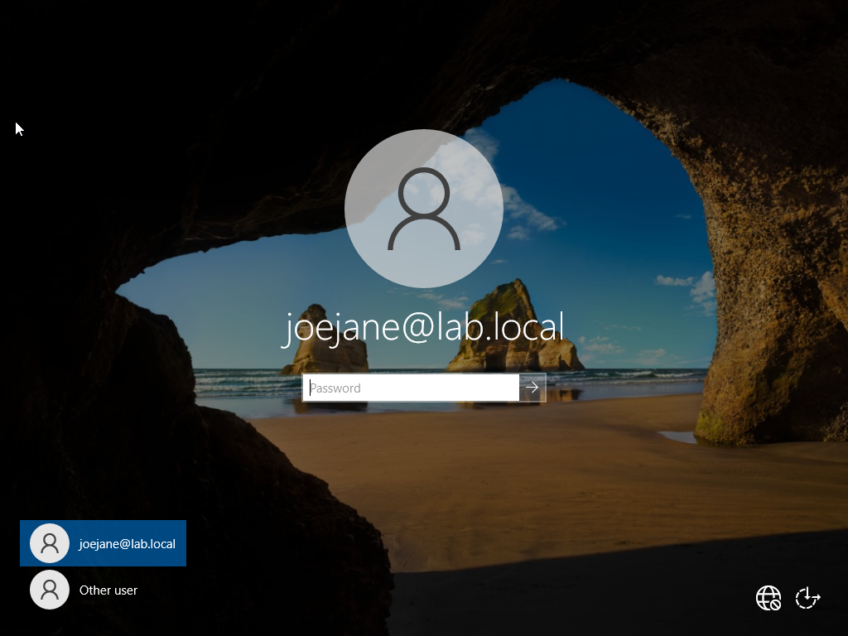

Step 3: Password Reset
- Log back in as LAB
- Open AD Users and Computers → Users → Right-click jdoe → Reset Password
- Set new password (TempP@ss123)
- Optional: Check ‘User must change password at next logon’
Screenshot: Lab1_PasswordReset.png
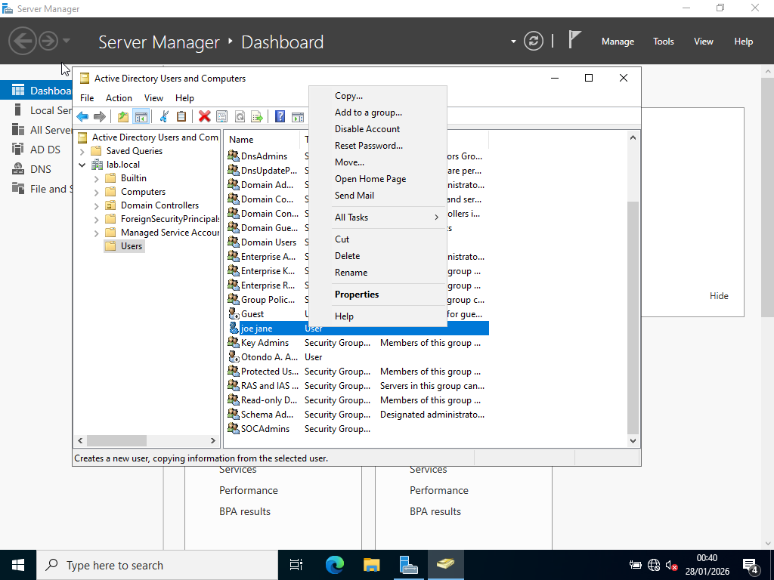

Step 4: Account Enable/Disable
- Check if jdoe account is disabled (down arrow on icon)
- Right-click → Enable Account if necessary
- Ensure account is not locked out
Screenshot: Lab1_AccountEnable.png
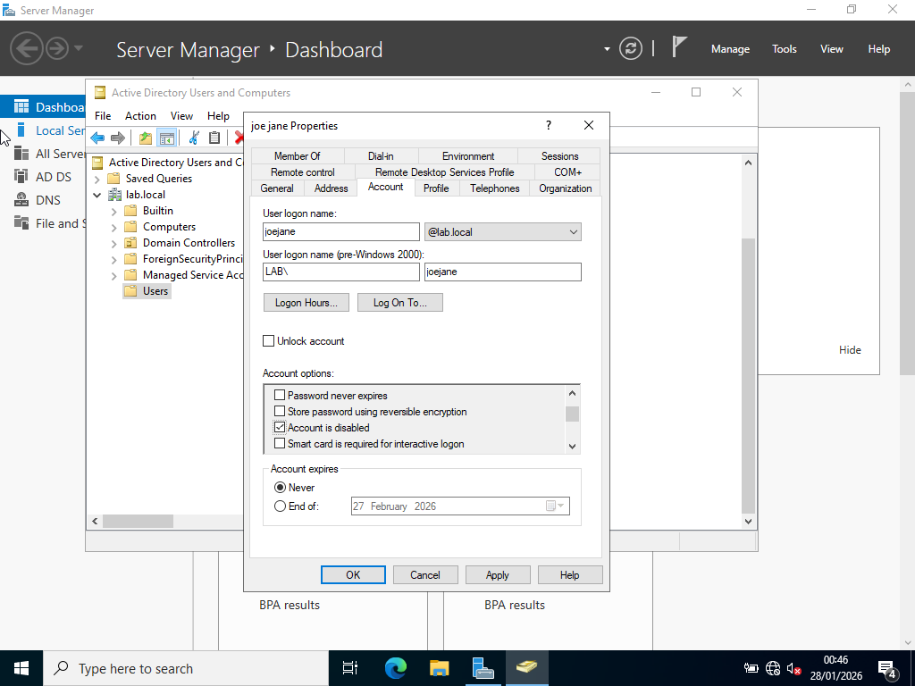

Step 5: Group Membership
- Confirm jdoe is a member of LabAdmins
- Add a second user to LabAdmins
- Verify members in the group
Screenshot: Lab1_LabAdminsGroup.png
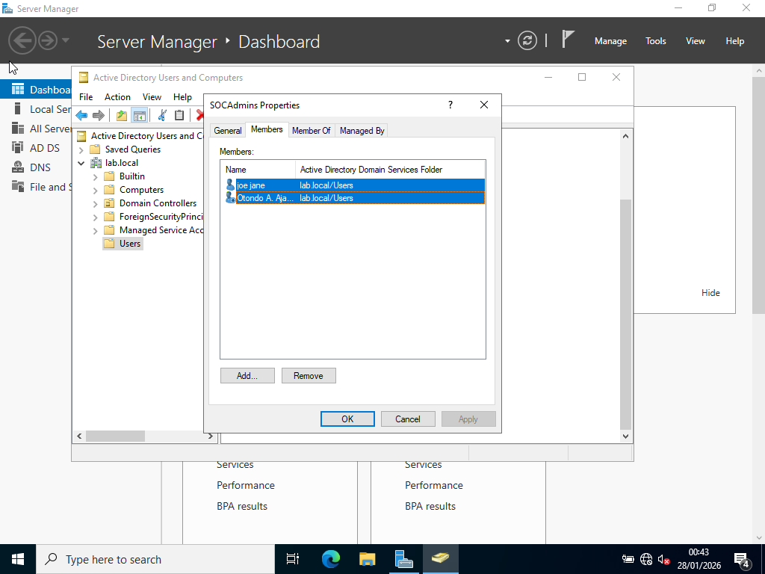

Troubleshooting Notes
- Login failure due to account disabled → resolved by enabling account
- Login failure due to password mismatch → resolved by resetting password
- VM keyboard focus required for Ctrl+Alt+Del operations

Lessons Learned
- Domain Controller login behavior differs from normal Windows PCs
- AD objects (users, groups) persist even after VM restart
- Keyboard capture issues in VirtualBox are common and expected
- Real-world IT support skills include diagnosing login and account issues

Next Steps
- Lab 2: IT Support Ticket Scenarios
- Lab 3: Windows Server Services & Event Viewer
- Lab 4: Azure AD / Microsoft Entra Basics

